A Vision-Casting Mission Trip for

Emerging Presbyterian Leaders: **ETHIOPIA**

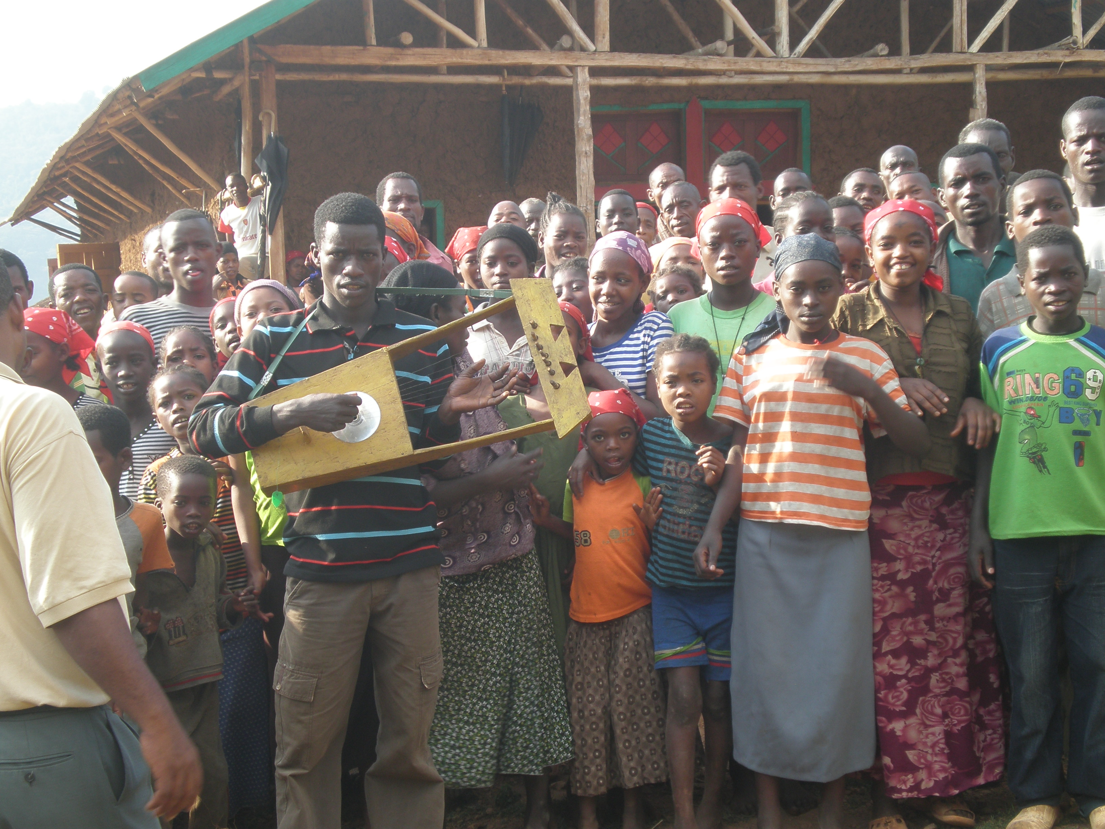

Trip leaders:

Rob Weingartner

Executive Director

The Outreach Foundation

David Dobler

Former pastor, presbytery leader and General Assembly moderator (1993)

**The Ethiopian Evangelical Church Mekane Yesus has grown from 50,000 members to eight million in the last 60 years!**

Oct 28 – Nov 9, 2019

Harold Kurtz described Ethiopia this way: “The Gospel is out of control!”

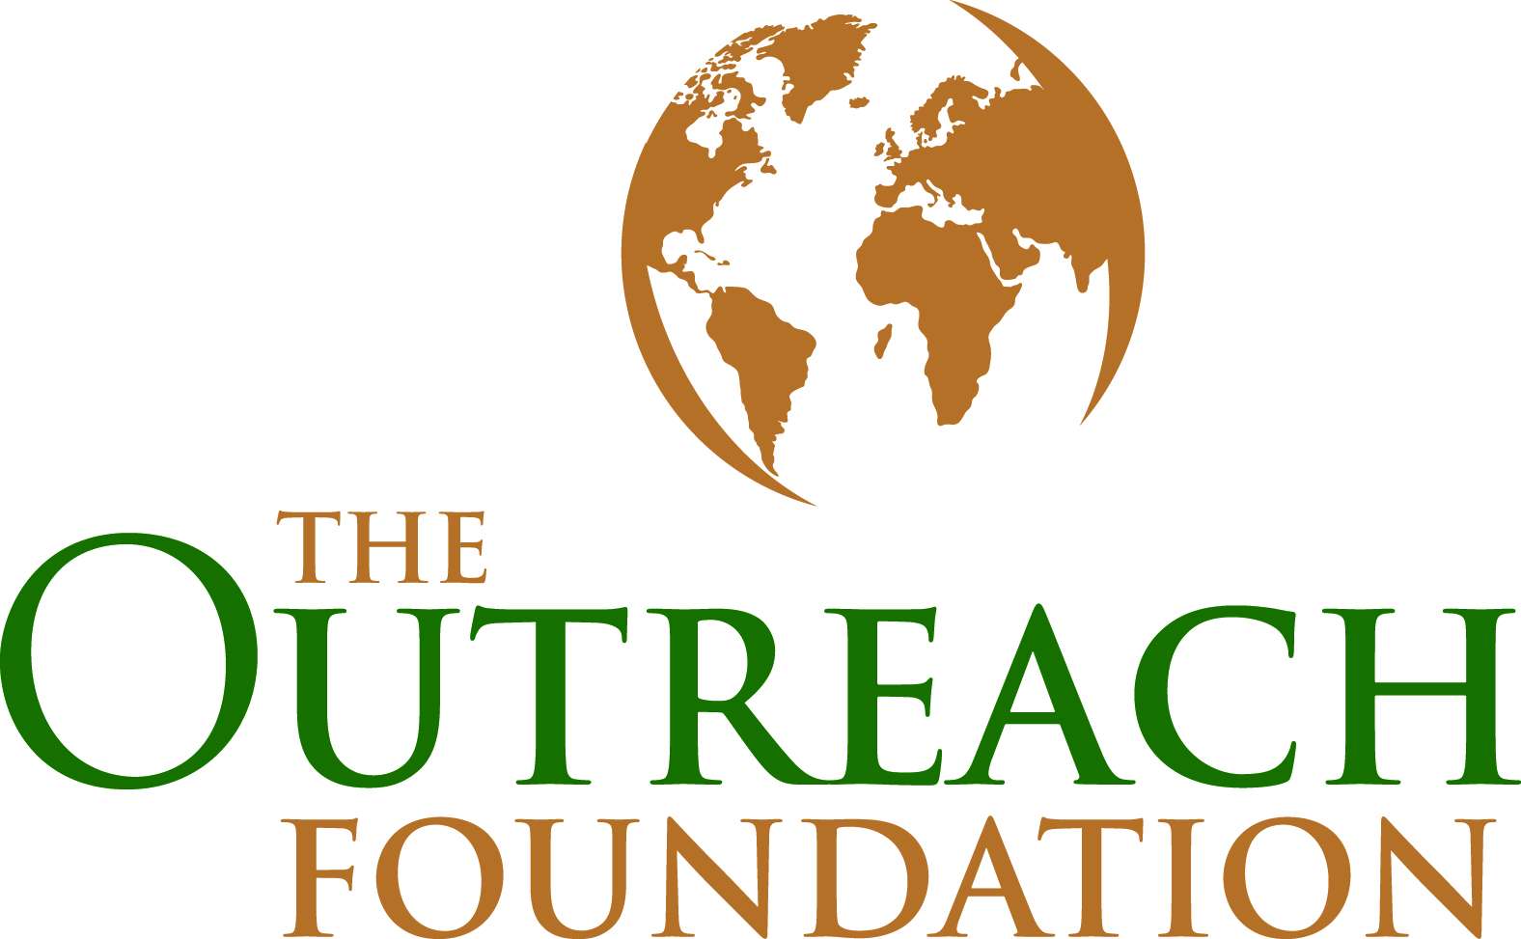

This travel opportunity is offered by The Outreach Foundation for young pastors, emerging Presbyterian leaders who have been in pastoral ministry for around a decade or less. The purpose of the trip is to listen and to learn from strategic leaders who are impacting a nation with the Gospel of Jesus Christ. The group will be exposed to transformational ministries in the areas of the proclamation of the word, compassionate service, work for justice, and leadership development.

We will spend time sharing life and faith in Addis Ababa, one of Africa’s largest cities, and in rural settings. We will have informal and formal meetings with pastors, local congregations, local youth, theologians, and other key strategic leaders who are bringing change and transformation within their local context.

The estimated basic trip cost of $2900 includes international airfare, visa, transportation, food and lodging in Ethiopia. It does not include your domestic travel to our group departure city, Washington D.C. (Dulles). Scholarship assistance will be available.

We pray and expect that this trip will have a tremendous impact in the lives and leadership of those who participate.

For more information please contact rob@theoutreachfoundation.org.

*Many churches in the Majority world are growing by leaps and bounds at a time when the Western churches are in decline. What can Christ followers in other contexts and cultures teach us about participating in God’s global mission and serving on our own mission field here in the U.S.? Come and see!*

Overview and Purpose



The Outreach Foundation 381 Riverside Drive, Suite 110 Franklin, TN 37064 615-778-8881