The Outreach Foundation
Cuba Team Journal
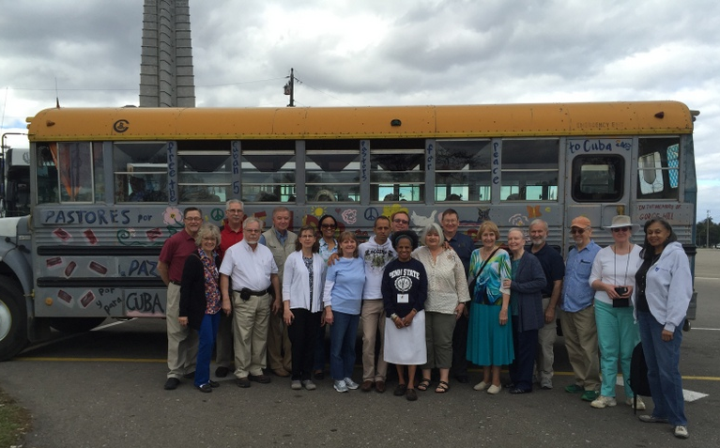
February 5 – 13, 2016

Friday, February 5, 2016---Dorothy Lekarczyk
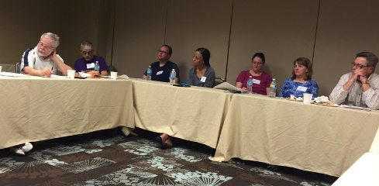
All 18 of us gathered at our Tampa hotel, Presbyterians drifting in at various times during the afternoon, having traveled from all across the country. It soon became apparent that we would become a congenial group--perhaps we already were! Having checked into our respective rooms, we gathered in one of the hotel conference rooms to share, over pizza and salad, who we were and why we had decided to take this trip to Cuba. Three of us, as well as Marilyn Borst (leader, guide and caring den-mother), had traveled to Cuba on a similar trip, exactly one year ago. Before retiring for the night, we apportioned items we had brought with us, so that we all could share in the "backpacking" of our gifts to the churches we were about to visit. Congeniality already was apparent!
Saturday, February 6, 2016---Dorothy Lekarczyk

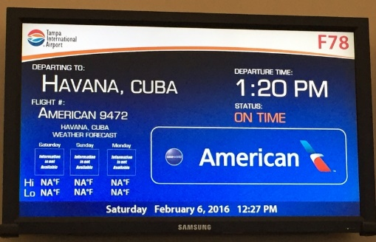
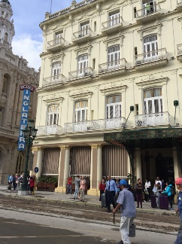
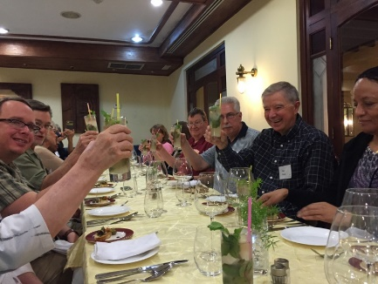
We were up early, ready to begin our adventure! Having breakfasted at the hotel, we began departing by van to the Tampa airport. We left early (beginning a little after 7 AM), to not be late for our flight which was leaving at 1:30 PM! We juggled passports, Visas, authorization letters to travel to Cuba issued by The Outreach Foundation, luggage, etc.--we did a good job staying together. After being checked in to our American Airlines charter flight, we wandered in sub-groups around the airport, keeping ourselves and each other occupied until it was time to board.
How exciting when, after just an hour's flight, we spotted the land many of us had longed for years to see--CUBA! The lighting in the Havana airport is dim, much like the lighting in the Moscow airport, reflecting either the Russian influence on Cuba, or simply the lighting typical of the 1950's, or both. Going through customs in another country is always a bit bewildering, even when one knows generally what to expect. We were shepherded along efficiently by our Cuban guides and finally, we were in our travel bus, on loan from the seminary in Matanzas. The bus is decorated like a 1960's hippie bus so, as we were eagerly watching the Cubans and the scenery, the Cubans certainly were eagerly watching us! As we headed to our hotel in Havana, we experienced a gentle rain sprinkling over this sunny day, with a lovely temperature and a slight breeze. There was live music greeting us outside the Inglaterra Hotel. We checked in, exchanged currencies and got settled into this oldest hotel in Havana, established in 1875!
Pastor Herb Coddington led our devotions that evening, focusing upon serving, and emphasizing that a good server makes him/herself available, is attentive to the person, anticipates needs, and is grateful and appreciative. An inspiring message, helping us to develop a serving mindset as we prepared for this week of learning to understand the needs of the Cuban people and their churches. Herb helped us greatly, in our preparation to establish our new relationships.
We concluded our first day in Cuba with dinner at Armatures de Santander (the Shipbuilders) restaurant, in a private dining room. Our delicious dinner included pate, mojitos, pumpkin soup and a choice of chicken, mahi mahi, pork or shrimp---and profiteroles for dessert! The chef was an expert! Moraima Gonzalez, who arranged our trip on behalf of the seminary in Matanzas, spoke about Cuban history and current cultural life. This day was a perfect introduction to Cuba!
Sunday, February 7---George Pasley

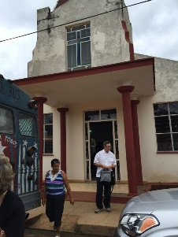
On Sunday morning we loaded on our bus for our first venture (and ad-venture)! The roads were relatively good getting us to Los Palos, which was a small village 70 miles away from Havana. Los Palos church is pastored by Rev. Izett Sama, who is relatively newly ordained. They actually worship on Saturday nights, because more people can attend then than on Sunday, so we missed worship but we were there for their weekly Church school, which is for all ages.

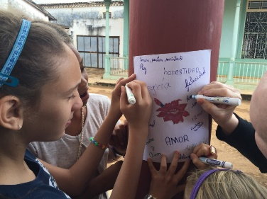
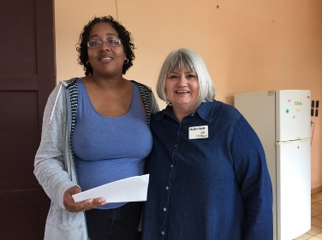
When we got there all the students were in the sanctuary, for the multi-generational part of the lesson. The lesson was on the miraculous catch, as told in Luke, where Jesus tells Peter and his helpers to cast the net on the other side- and Peter catches a catch so big that he is filled with fear. Pastor Izett said that Peter was changed by what Jesus DID, not what he said. The different age groups- I think 3 for children (maybe there were four) and one for adults- came up and shared words that would indicate how we should act towards others that might be transforming ways to act. I noticed that Amistad was named by every group, which our translator Yosmel translated for us as “friendship-ment”. I think that meant that friendship as a verb, not the normal noun we use it as (more like “friending” somebody on Facebook has become a noun). They had to share their words with the large group.

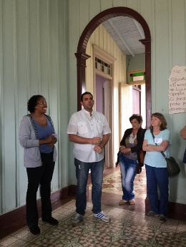
Then, each group went off to a separate lesson. The adults had to match off with somebody we did not know- for most of us, that meant an American was matched with a Cuban. Pastor Izett led us through a series of actions that explored levels of engagement with our opposite, encouraging us to get out of our comfort zone. We had to pantomime what excited us about our current walk with the Lord, and share one word we think is needed for change to happen. We also had a group discussion of the scripture lesson. After the separate lessons all the groups came back and gave reports. The adults had one Cuban speak and one American speak. Rob Fulton spoke for us, and a woman spoke for the Cubans. I did not get her name but I got her picture, she was quite animated and I noticed that several of the Cubans I was sitting with were a bit amused by her gestures and excitement. They want me to send them her picture, so I got their address. The youth group teens role played their lesson.

Later we walked across the street to see their new property, which they are trying to use in a variety of ways. It is a spacious multi room house, with a nice patio. They envision a place for artists to do art, and there are currently some art projects going on, many of them encouraging young artists. A place is needed for ‘vulnerable’ groups- perhaps these are AIDS patients, or some other groups vulnerable to shame or scorn. At the present time they are doing some things with elderly folk in the village and families taking care of the elderly. The teenagers in the town need space, and the church has done something with the soccer team. They might benefit from a space to watch films and to debate, or simply a space where they can ask questions and express themselves, as well as a place where children can do crafts. They want the space to be used not just for the church, but for the village. They also have a program, where women can discover their talents and sustain themselves, and move forward. Currently they are learning sewing and manicuring, and the goal is to have an alternative economic co-op where women can learn other trades, and be free of abusive relationships. They are trying to help families with abuse and alcohol problems.

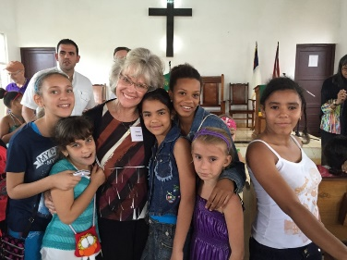
A Living Waters system is installed at the church, villagers can come anytime and get drinking water. They also have a food program for the elderly. Lunch at Los Palos was our first meal with a congregation! They prepared a pan-fried ham with melted cheese and alight batter; kabobs (both chicken and pork); black bean soup; rice; yarrow (tasty!); salad, friend plantain, and they took great delight in our pleasure with the food. I have some marvelous pictures of the happy cooks at work. The Church at Los Palos has begun a small children's library; the pastor showed me two shelves that were stocked with children's books, many of them in English. Since I came home, I found one Spanish and three English books for children that I'm going to try and mail to them. I'm certain that I could find hundreds more, so this first attempt will reveal how expensive such a venture might be.

Monday, February 8, 2016---Michael Shum

Hotel Inglaterra

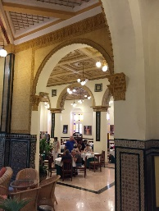
The day began personally with a trip to the open air, roof top terrace of Hotel Inglaterra in Havana for early morning pictures from a unique vantage point. The scene varied from the beautiful capitol building under renovation to rooftops of decaying buildings within the vicinity of the hotel to cars from the 1950s lining up as taxis in the boulevard in front of the hotel to a view of Central Park across the boulevard. The morning continued with a breakfast buffet in the hotel’s Restaurante el Coloniai. The menu consisted of a standard fare as with most days there: pancakes; over easy fried eggs; runny scrambled eggs; spaghetti; squash; bacon; sausage or chorizo; fish; ham and cheeses; cereals; various fruits; breads and pastries; milk; juices such as orange, grapefruit, or papaya; and coffee. The presentation was as would be expected in any Four Star hotel, with mosaic tile as a background in both the serving stands and the walls, as well as tables with white cloth tablecloths. The restaurant always opened early before our group had to travel, which permitted conversations and small group gathering time each morning. The lobby was often full of guests awaiting a day of touring with any number of companies which could be scheduled in the hotel. Lobby walls displayed the history of the hotel with illustrations of some of its most famous guests. Dollars could be exchanged for the day at the front desk for CUCs at the rate of 78 CUCs for 100 Dollars.

Bus Travel

Following breakfast, the group walked around the corner and boarded our seminary bus, which continued to garner admiring looks from the public, for a ride to our first destination. The hippies in the group remembered when it was their dream back in the day to own a bus like this one. As was our custom, the day and each trip began with a prayer offered by a member of the group. Along the journey through Havana to Plaza de la Revolucion, Yosmel pointed out buildings and places of interest. One of the most incredible sites passed was Quinta de los Molinos, the former residence of General Maximo Gomez set in the midst of lush botanical gardens once owned by Havana University.

Plaza de la Revolucion

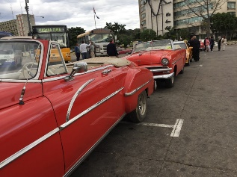
At Plaza de la Revolucion, the group took a group picture by its bus. Yosmel provided a bit of the history of the square and informed the group about some of the buildings surrounding the plaza. The group continued to be fascinated by the cars from the 1950s that lined one street and circled the plaza as taxis. Some of the owners explained to group members the extent of the care they take with those automobiles to keep them running and in such great shape. The plaza was a huge, empty square which fills at times with public gatherings to hear such persons as Fidel Castro or the Pope address them. The plaza is dominated by the Jose Marti Memorial, which was being used for a private governmental event and not open to the public that day. On most visits, the memorial would have been open for visitors to view the surrounding area from the top. Buildings of note surrounding the plaza included the National Theater of Cuba, the Ministry of the Interior, the Ministry of Communications, and the National Library. The Place of the Revolution is the seat of the Cuban government and Communist Party. The Ministry of the Interior and the Ministry of Communications were of particular interest as they contained matching steel outlines of Che Guevara, with the quotation “Hasta la Victoria Siempre,” and Camilo Cienfuegos.

Bus Travel

Following our visit to Plaza de la Revolucion, the group travelled for a short time by its bus to San Francisco de Paula, a district in the eastern section of Havana, about 15 miles from Old Havana, to the location of Finca Vigia. The streets were incredibly bumpy for that ride. During that journey, the group was able to observe a variety of structures on its own through the bus windows, such as old business buildings with Corinthian columns, gas stations, store front shops for food mainly, free standing and modern snack shops, dilapidated multi-unit apartment buildings with Soviet-influenced architecture, and residential housing in all states of repair. Normal activities and casual dress were reflected by individuals going about their ordinary business much as would be observed in any U.S. city.

Finca Vigia

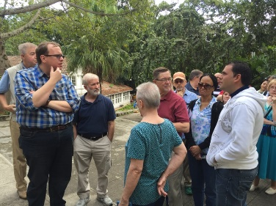
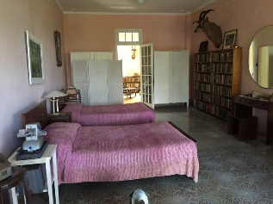
The group then visited Finca Vigia, the Cuban home of Ernest Hemingway, located on a hill in San Francisco de Paula overlooking Havana. Yosmel again led the group during its visit and provided background information about the site. The group was able to look into the house through open doors and windows, as well as tour the grounds with its lush vegetation, the pool, and the fishing boat of Hemingway, the Pilar. Finca Vigia was Hemingway’s Cuban home for 20 years and the place where he wrote much of For Whom the Bell Tolls and The Old Man and the Sea. Most of the original furnishings, decorations, books, hunting trophies, and papers of Hemingway remain much the same as when he left in 1960. Even a Salvador Dali creation hangs on the wall. After the revolution, the property and most of its contents became the property of the Cuban government and was eventually turned into a museum. Controversy remains as to whether it was a donation by Mary Hemingway or was a subtle appropriation by the government. Regardless, the sense of history was overwhelming as visitors could view Hemingway’s books, hunting trophies, and furniture just as he left them, in addition to touching his fishing boat. Disrepair accumulating from the past 60 years was evident; however, digital copies of 2,000 of his papers and documents there have been transferred to the John F. Kennedy Library in Boston through a cooperative effort by a private U.S. foundation and the Cuban government. In addition, a new building with library-quality atmospheric controls is being constructed on the grounds to house his books and records. Approximately $900,000.00 worth of materials is being shipped from the U.S. to Cuba for this project. Before leaving, the group was again was able to view vintage automobiles used as taxis and enjoy drinks made by employees crushing sugar cane on the premises. Upon departing the site, the group walked through a residential neighborhood to the bus. Lush vegetation and flowers surrounded most of the houses.

Bus Travel and Calvin Bust

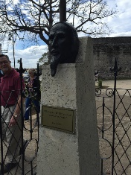
During the bus ride from Finca Vigia to Old Havana, the group passed through residential neighborhoods with houses in both a state of disrepair and newly restored. During a bus stop the group was able to visit and observe close-up remnants of the original wall surrounding Havana, along with a bust of John Calvin, known in Cuba as Juan Calvino, marking his 500th anniversary in a small park nearby. After that stop and along the way to Old Havana, the bus passed 14 year old girls posing for their photographic sessions marking their age of coming out. In addition, the group could observe the various modes of transportations always present on most any street or highway: horses; horse drawn wagons; bicycles; pedicabs; antique cars and trucks; modern, foreign cars and trucks; and buses of all sorts, including modern and climate controlled motor coaches and tour buses. Areas of the Bay of Havana were passed and observable across from the bus stop.

Old Havana (La Habana Vieja)

Upon the bus parking at the harbor and the group entering Old Havana, it was evident that archeological excavations and the rehabilitation of many structures in Old Havana were ongoing. Old Havana is one of 15 municipalities making up Havana and is a UNESCO World Heritage Site, dating back to the 1500s. The time being early afternoon, the group had lunch at El Restaurante La Floridana. The group was able to order off the menu, while beginning with a mojito. A full dinner consisted of a choice of beef, chicken, fish, or pork, along with bread, salad, soup, rice and black beans, bread pudding, and a drink. The full red snapper dinner was $18.00 CUC. Rest rooms were available in the adjoining hotel; however, tipping the attendant was expected.

Walking Tour

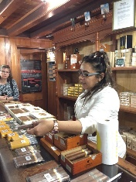
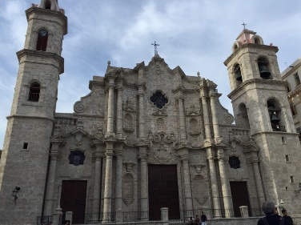
Following lunch, the group went on a walking tour through numerous squares, with Yosmel as its guide. Along the way to the squares, the group passed by the oldest house in Havana and the Hotel Ambos Mundos, the hotel in which Hemingway rented a room prior to his move to Finca Vigia. Cobble stone streets were divided into sections by cannon barrels implanted with their muzzles buried. Dogs abounded while sleeping in the sun. Areas visited included Plaza de Armas, Plaza de San Francisco, Plaza de la Catedral, and Plaza Vieja. The group’s visit to Old Havana included a stop at the Havana Club (El Ron de Cuba) for the purchase of Cuban cigars and rum, as well as at a post office (Correos de Cuba) for post card stamps. After those stops the group had free time to visit an art gallery or wander individually. Some of the group visited shops along side streets while others stopped at Café el Escorial to relax, where service was slow to allow each cup of coffee to be brewed individually. Upon leaving Old Havana to board its bus, the group could see the fortress and the statue of Christ on the other side of the bay.

Bus Travel

During its bus ride to the Luyano Reformed Presbyterian Church, the group passed by the first hospital in Havana. In addition, the group was able to observe some of the activities along the bay, including industrialization.

Layano Reformed Presbyterian Church (Iglesia Presbiteriana Reformada de Luyano)
and
Reverend Daniel Izquierdo

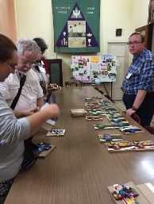
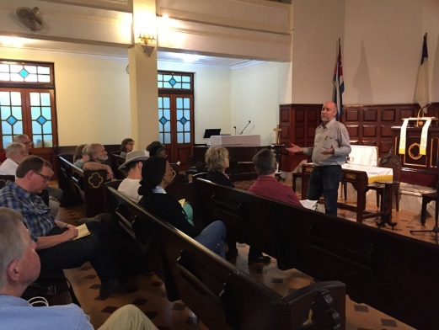
Following a short bus ride, the group arrived at the Luyano Reformed Presbyterian Church. The church was located in a typical neighborhood consisting of beautiful historic buildings in decay, along with buildings in the process of repair. The church itself was beautiful and well appointed. Children were playing in the street, and cats ran about the grounds. The group was first met by a member of the church who makes ceramic crosses in three sizes and in many designs. Most members bought several as special gifts to take back home. Following that opportunity, the group met in the sanctuary and was led in devotions by Kathryn. Kathryn observed we were learning about a different culture and were also learning about the perceptions of others about us. She asked us to consider what the Cuban people might think strange about us if they visited our home churches. After discussions, the group discerned that the Cuban people might note our absence of youth and our homogeneous congregations, while observing the symbols we have in common and the friendly nature of our congregations. John 15 was the center of a Scripture lesson, and the group song was “May the Mind of Christ, My Savior.” Devotions were closed with prayer. Those devotions were followed by team time, led by Marilyn, who reviewed the schedule for the next day. Reverend Daniel Izquierdo then addressed the group, detailing some of the history of the church, which began as a mission church in 1932, at which time the sanctuary was built and consisted of a congregation of about 100 members with about 70 worshippers. An elementary school with dorms upstairs once existed. He also explained the character of the neighborhood as a working class neighborhood, becoming poorer, with problems of alcoholism, drug abuse, and domestic violence, noting that the average work was paid in a local currency with a different value that the CUCs that our group traded in. Additionally he detailed some of the outreach activities of the church such as support for a year-long English class with a professor for a small fee, music with monthly concerts, a community water system dispensing 4,000 gallons a week, an after-school program, an exercise group, and a garden. He also detailed the history of the Presbyterian Church in Cuba, dating back to the early 1900s, noting that currently the largest church had 300 members, with many churches having an average of 40-50 members; that there are three presbyteries in Cuba with 33 churches, 21 mission churches, and 25 pastors; and that the demographics of the current church was about 75% women/25% men, with some young adults but mostly older members. Pastor Izquierdo also observed that the six year training program for pastors created a problem for growth and that flexibility might be the answer to so many mission churches having no pastor. He made note of the tension created by some Cubans leaving and some staying after the revolution, and even now as travel opens up. He further noted how change is coming with governmental programs, foreign investment, and the internet availability. He did observe that change will create challenges for the church with more people in need coming to the church while others finding fault with the church for not speaking up more following the revolution and its association with the Marxist government. Glen closed the presentation by presenting Rev. Izquierdo with a cross and offering a prayer. The visit ended with dinner prepared by church members. Dinner consisted of salad, chicken noodle soup, chicken and rice, juice, ice cream, and coffee. We were conscious that we were able to eat food prepared for us in the church, similar to that prepared in other churches and restaurants, which would be unavailable to most Cuban workers in the cities with a limited income.

Bus Travel

Following the group’s visit at the Luyano Reformed Presbyterian Church, the members returned to the hotel by bus. As with most trips, part of the bus ride was a working session with Marilyn, which detailed a reminder of the schedule for the following day and the designation of a journaler. Plans were also made for gifts for the children during the next day’s visit to a church, as well as donations to those persons in Cuba who made our visit possible. The bus always parked along the street intersecting the boulevard in front of our hotel. Upon rounding the corner, the group always passed by the Opera House (Gran Teatro de la Habana), the façade of which was always lit up at night, next to Hotel Inglaterra.

The group returned to our hotel for the evening. Upon entering our rooms, we were reminded of the hospitality of the service staff. The end of one of our beds contained the towels for the next day, forming a special display of an animal or a word. That evening the display in our room spelled out the word CUBA.

Tuesday, February 9, 2016---Jennifer Horton

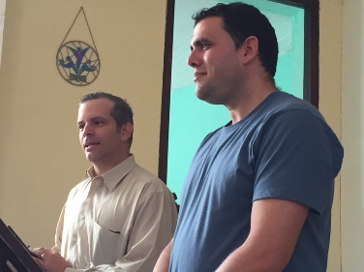
Leisurely beginning today with hotel departure at 10AM...our destination this morning is the town of Guanabacoa (name means "place of water") to visit the Guanabacoa Presbyterian Reformed Church and to meet Rev Yoelkis Sierra, a newly ordained pastor...he has worked with this congregation since 2013 as an elder and seminary student. The church is 114 years old; it is the first evangelical protestant church in the area...missionaries founded it when only a catholic church was present.
This community was established to be the home of workers who were employed in Havana City. Population is mostly African Cuban; Rev Sierra observed that it is a place where African religions are practiced primarily; yet, there is also a Jewish community present. Making further comment regarding religious practices, he said it is not unusual for a family to have multiple religions represented in the same household. It is interesting to note that children are allowed to participate in programs and worship of the congregation although their parents are present only for special events. The parents have significant trust for pastor and congregation.
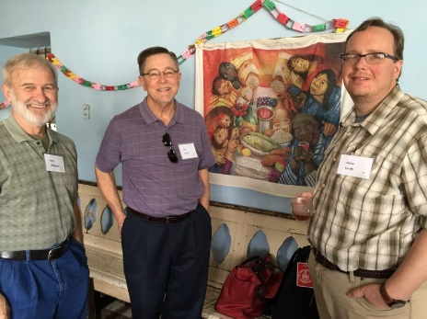
The church has strong social outreach services. Ministries include HIV/AIDS patients and their families, children, elderly persons, clean water project, a full time greeter, distant prayer houses, Bible study, and worship services. The church has worked to provide aid to HIV/AIDS patients since 2007, focused on ending discrimination against these persons and their families...municipal awards have been received for their work in this area. Children participate in the "Growing In Jesus" study program, enjoy social excursions...including sleepover events with supper, games, and teaching which ends with breakfast for them and their parents. Another group specifically addressed is the elderly regarding nutrition...lunch is served every Sunday to older adults to ensure they get a balanced meal weekly, anywhere from 12-25 persons are served. The Living Waters of the World program has been in place since 2014; its impact cannot be measured regarding its benefit to the community. Clean water makes healthy life possible. The church did not have the means to fund the program on an ongoing basis; so, a can for donations was placed to receive contributions...no suggested donation...just give what you can. These monies pay the salary of the clean water operator and the electric bill for producing the water. The church hired a woman to keep the doors of the church open and to greet anyone who stops to enter...in the community, the church had been known as the church with closed doors, now it is the church with open doors. Prayer houses at distant locations are like satellite churches without a full-time pastor...daughter churches. Bible studies are conducted for the members of the congregation on a weekly basis. Worship services are held every Sunday with Rev Sierra officiating...50-60 people are in these services with more in attendance when the HIV/AIDS families attend.
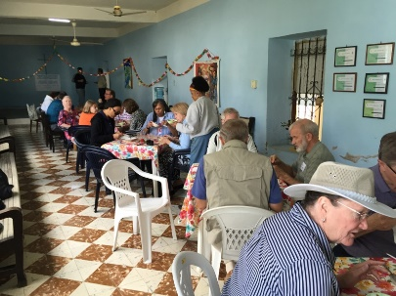
Rev Sierra shared some social insights regarding the Cuban population. The population is ageing and there are many people who live in multiple generation households from necessity. First, there is lack of housing; second it takes multiple salaries to support a household. The average wage is 20 CUCs ($20 USA) a month and the retirement wage is 10 CUCs ($10 USA). Diversity of needs and personalities contributes to intergenerational strife. Many couples have opted to postpone marriage and childbearing; abortion is the primary means of birth control and has no stigma. The government is now paying couples to have children to increase the birthrate. Interestingly enough there are persons with no children who are retired who have asked the pastor to match them with a family so they might have a source of care while providing a place for the family to live with the understanding that at a future time the family will inherit the property. Special note...there is private ownership of houses. In Cuban culture, the family is very important; hence there is a need to establish some type of family connection when a person or couple has no family. Rev Sierra said the request to match people with people for family purposes is difficult on many levels...abuses are possible from either party and the pastor is in the middle of potential conflict. Yet, the pastor sees the need.
Additionally, comments were made about the need for the Church outside Cuba to learn that congregations can and do exist in a socialist society. A need was expressed to have even greater access to religious books printed in Spanish. Rev Sierra observed that the future is unknown, but the present is filled with optimism. Yet, even if the government were to limit the mission of the church severely, the church would continue; after all the Church has been challenged since its very beginning.
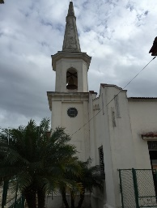
After lunch, we traveled to the Guiness Church to meet with Rev Abel Mirabel. Our route took us from two lane roads to an eight lane highway to two lane roads again. As we traveled, the road surface was a ribbon of potholes of which some were significant. Drivers drove in and out of lanes to avoid the deeper ones...one hole was so large that a 50 gallon drum was up-ended in it with 50% of the drum covered. Looking out the windows of the bus, we could see cattle, goats, and horses tethered with ropes on the grassy medians and along road sides to forage...a unique alternative to cutting grass of medians by road crews in the USA.. Another observation regarding roads...barb wire fences controlled access to roads rather than close link fencing. Fence posts were a mix of the customary post and growing trees...evidently green poles had been used as fence supports at close intervals...most poles had sprouted, becoming trees. At one point on the drive within vision through the windshield of the bus, we could see a horse drawn cart, a motorcycle with side car, a 1940s era car, a modern tourist bus, a freight truck and a compact car...what a contrast...all vehicles using the same roadway with the slowest traffic staying to the right. Cuba is certainly a land of dramatic contrasts. Earlier in the day, Dr Sierra referred to Cuba as a place with a "highly literate population (99%) with first world education and third world jobs."
Soon, we arrive at the next destination church which is located in a town of about 70,000 people...the church in Guiness is one of the largest in Havana Presbytery with 140-180 persons attending worship weekly. It too has been an active congregation for 114 years; it had never been without a pastor...not even at the time of the Revolution. Rev Mirabel has not been here very long, previously he was pastor at the Guanabacoa Church; Rev Sierra was mentored by Rev Maribel. As we walked into the sanctuary, we could see that it was already set for Lent with its purple paraments in place and communion set on the sacrament table. The chancel area displayed the Cuban flag and the Christian flag...much like displays of flags in USA sanctuaries.
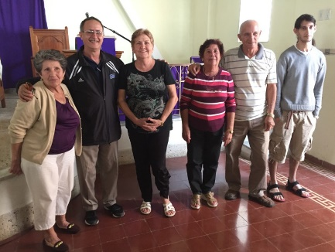
Social outreach is important here also...care for the community helps sustain the congregation. Important projects include focus on the elderly, a clean water project, a music ministry, a cinema outreach to youth, assistance to people recovering from cancer, weekly English lessons, food for vulnerable people, and plans to start an HIV/AIDS ministry. The church identified a need to help elderly people recover certain human values through use of history, psychology and sociology disciplines. More than 300 people come to the church to get clean water through the Living Waters for the World program on Mondays, Wednesdays, and Friday; congregation members help to distribute water offering words of blessing. They also remind individuals not to use coarse language and to wait patiently. A strong emphasis is placed on music with a band composed of the pastor's family and several members from the local community. They play for services and special concerts offering a diverse mix of music..."we play strong (loud) music for special concerts, we play softer songs and traditional music for worship services," says the pastor. Every Friday, films are shown for youth as an alternative to going to the main park to access the internet through wifi...this is a cooperative project with the Baptists. About 20 youth participate in this no fee program. The assistance given to recovering cancer patients includes access to a nurse, paying for medicines, and some additional monies for people in the final stages of cancer. English lessons are given each Saturday for adults and children. One of the newer projects is providing better nutrition for vulnerable people. Rev Maribel said, "everybody eats, but not in the same way." Beans and rice are a staple with each person receiving a ration card for these staples along with meat and cheese when available. Looking toward additional ministries, he also stated that he has plans to begin a new program soon with families of HIV/AIDS patients...he had such a program in his previous church in Guanabacoa .
One of the elders proclaimed with a smile going to her eyes, "This is a happy church!" Rev Maribel asserted that the church has lots of support in the community and it is filling the spiritual emptiness of the people. A question was posed regarding the greatest challenges and strengths of the Church in Cuba by Rev Coddington. Challenges were identified as out-migration of youth, the deaths of people trying to flee Cuba who died in the Straits of Florida, and the defections of high profile citizens when outside the country. (Just recently two baseball players had defected as had the national moderator of the Women's Fraternity.) He saw the USA embargo as problematic in two ways...lack of goods and as an excuse by Cubans to ignore their mistakes. Also, he expressed vehemently his concern for the USA embassy's uneven process for granting visas...he had recently had a unpleasant personal experience regarding a visa request. He made a very strong statement about former communists who had left the country and were now living in the USA...all because the officials were uninformed.
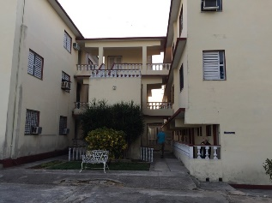
As strengths were identified, Rev Maribel pointed with pride to the fact that the Presbyterian Reformed Church has never lost its identity since it was established. It survived revolution and strained relations with the West during the Cold War and it was there to help the people when the Soviet Bloc fell apart and all foreign aid from the USSR was withdrawn. It continues to be viable in the changing world of today. Next he pointed to the verbal and spiritual presence of the PRCC in political and social environments. It was through the ongoing efforts of churches in Cuba that the socialist government removed its atheistic language from the national constitution in the mid 1980s. In 1989, Fidel Castro declared, "the Church is to be respected for the help it gives to the people." Rev Maribel is a man of great passion, who is a major leader in the Church in Cuba.
Later, our journey continued to the seminary where we checked into our rooms and unpacked our luggage...a brief respite before the day's events. It was a long day, but filled with valuable observations.
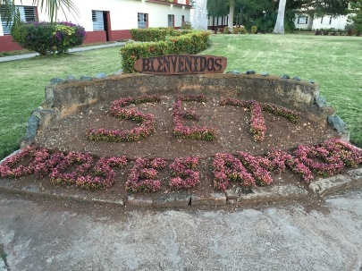
Personal note... Reflecting upon the day's events, I am most touched by contrasts of the joy of a new pastor and the pain of an older pastor. Each is living the reality of his current location...spiritually, emotionally, physically, socially, politically, culturally...all combine to create the environment of each pastor's reality. Exhilaration and experience are valued in all seasons of life... along the way exuberance requires temperance and experience requires innovation. Just as Scripture posits, perseverance in all things for the Kingdom will allow us to gain the prize. It is my prayer that these two pastors will continue to be undergirded by the Holy Spirit as they continue the ministries that GOD has ordained for each.
Wednesday, February 10, 2016---Emilee J. Taylor
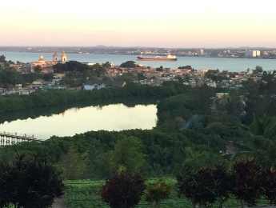
A few of us gathered at 6:00 am to see the sunrise at the seminary. Unfortunately, it was cloudy, however, the fellowship among the early raisers was enjoyable.
8:00 am – 8:30 am - We started our first day at the Seminario Evangelico de Teologia (SET) in Matanzas City, with breakfast at the campus cafeteria.
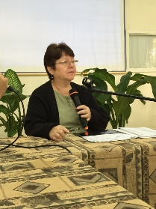
8:45 am - After breakfast, we reported to the classroom building near the cafeteria for a presentation about the seminary. We met with Elizabeth Gonzalez who began her presentation with a video about the seminary. It was a pleasure to see images of some of the pastors that we had met in Havana prior to our visit to SET in Matanzas City.
Sampling of Seminary Facts:
- Opened in 1946
- Name of seminary means Peace and Tranquility
- Offers residential and non-residential services
- Has distance programs in Havana and East Cuba
- Approximate enrollment: 444 Students/ 53% Women students/ 16 professors
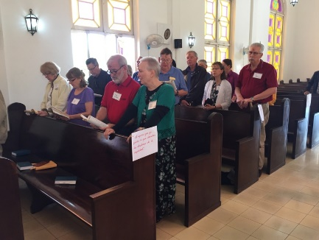
SET is a key partner with The Outreach Foundation. Maintenance of the campus is difficult and in need of support. Strategies are needed to provide support for the seminary. The Foundation will continue to support the SET. Our donations to the foundation will aid in the support.
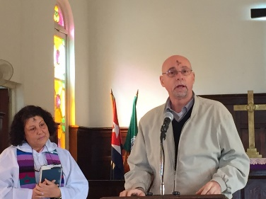
9:45 am – At the conclusion of the presentation, we walked to the chapel for Ash Wednesday Services with students and staff of the seminary. During the service, we were encouraged to walk by the pews to read passages encouraging us to forgive and repent during Lent. We were introduced to the congregation by the President, Rev. Dr. Carlos Ham, at the conclusion of the service. The gift of wand scanners was presented to the students as a gift from our team.
11:00 am – We were dismissed to return to the classroom building to view a presentation about the “Women Weavers”. Our resident poet, George Pasley, read his reflective thoughts in a poem titled, “As Dusk Settled”. We discussed the “Living Waters” purification system provided by various American Presbyterian Churches through the Outreach Foundation. Established in 2009, there are approximately 37 systems throughout Cuba. SET has a garden which provides food for the community as well as the seminary, selling vegetables once a week.
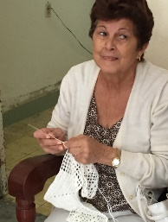
We were introduced to a women’s group called the “Weavers of Hope”. This group is made up of women various community programs through the sales of their hand knitted and woven creations. We viewed a documentary about the “Weavers of Hope”, highlighting the purpose and benefits of being a part of this uplifting and productive group of women. The documentary was filmed in 2013 by the United Church of Canada to highlight the anniversary of the women weavers. After the video, we were able to support this great group of women, and purchase items made by the women weavers. This group has developed a bond and is a blessing to those who are a part of the weavers.
12:30 pm – We had lunch at the seminary cafeteria, with a short break.
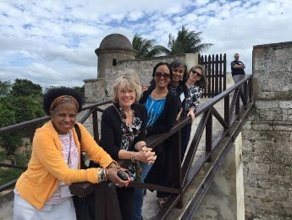
2:30 pm – We had a guided tour of the San Serveriro Castle (Slave Trade building and Prison) which described the history of the African Slave trade in Cuba. The tour included a museum which housed artifacts such as the chains used to control the slaves. Many came from Nigeria, Congo, and Benin. After the museum tour, we toured the prison area and the grounds.
Our next stop was to visit a store in downtown Matanzas known for crafting handmade one of a kind books. Unfortunately, the stock was low due to the store participating in a book fair in Havana. Some books were also on exhibit in New York City at the Museum of Modern Art (MOMA). We toured throughout the store, visiting the art gallery located on the second floor. The books that we did see, were outstanding works of art.
6:00 pm - After a break at Hotel Velasco in Matanzas, we returned back to the seminary for dinner. We had the opportunity to meet a PCUSA mission co-worker couple who will be teaching at SET: David Cortes-Fuentes and Josey Saez-Acevedo.
Evening Devotional
7:00 pm - During our devotional, we were blessed with another poem by George Pasley, which was a reflection of the day. Our group leader, Marilyn Borst, asked us to reflect on the day’s experiences.
Some reflections were:
- The placement of the cross on our foreheads were infused with a fragrance.
- The fragrance represented God’s sweetness.
- Many were touched by the video (documentary) of the “Weavers of Hope”.
- The gardens grown on the grounds of the seminary, impressed our group.
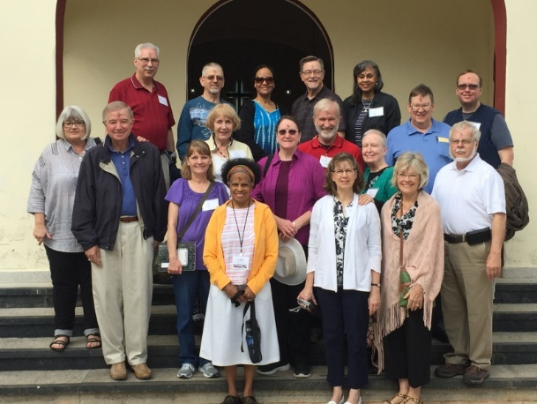
Jim Friedmeyer was our devotional leader for the evening. We were blessed to be able to pray and reflect under the stars of Matanzas City. The focus of the message was “Transformation”.
- The Cuban churches are dealing with spiritual and economic poverty.
- There is a need to be in partnership and listen to the Holy Spirit.
- We discussed how we have been transformed so far, from our trip.

Thursday, February 11, 2016---Jamie Smith

Thomas Merton once said: “Let me seek, then, the gift of silence, and poverty, and solitude, where everything I touch is turned into prayer: where the sky is my prayer, the birds are my prayer, the wind in the trees is my prayer, for God is in all.”
As we begin this new day here in this beautiful country that we have been blessed to be a part of for this all to short week, this is my prayer for our group this day, that we all recognize God is in all.
There is something profound and beautiful about listening to the hymn Revive Us Again echoing throughout the campus of SETs. May we all be revived in the day to come and with those we are to meet. Matanzas is a beautiful area. Made evermore clear by our first stop today, Montserrat, now a scenic overlook. Looking out over the beautiful vistas, it is easy for me to understand why this church originally built in 1871 based on a Catalonian monastery, was built here. You know that God is in all. No longer a church, but now a community center, I was disappointed that we were not able to go in and see the restoration of this church first hand, but, I can easily imagine the beauty held within.
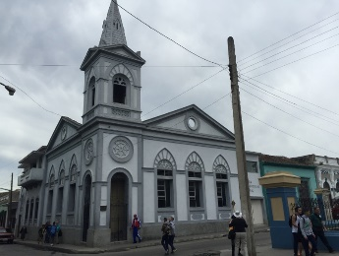
Today, we have two visits schedules with two different with Matanzas Churches: Central Presbyterian (Revs Ary Fernandez and Beidy Aragon )and Versailles (Rev Carlos Ham).
Our first stop with the people of Central Presbyterian, reminds me once again what I have seen time and time again with the churches we visit, we are welcomed warmly and kindly and lovingly. I’m beginning to think that this is the norm with Cuba.
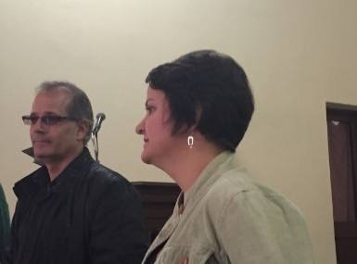
Reverend Ary is at the funeral home, but his wife, Reverend Beidy will be speaking to us. The church, founded in 1921 celebrated recently their 95th anniversary of organization. Central Presbyterian has a strong history in Mantanzas. And although Beidy and Ary have only been here for three years, they are doing holy work among the people.
Interestingly, they were both studying in Canada when they received a call to come home to Cuba. Ari was studying for his PhD and Beidy, her DMin.
Their first year at Central Presbyterian, they changed nothing and used it as a time of discernment and saw a need that they could address. The first focus of their ministry, youth and children. I currently serve a church that has a hard time finding Sunday School teachers for the youth, so I was excited to hear were able to not only find teachers but they developed curriculum. After three months, they began to see the harvest of their works, over 20 kids came to Sunday School and Worship services which has in turn led to their families coming too! Next, came a new focus on the ministry of Music. Music is a part of the liturgy of the church. One year ago, a children’s choir began for Christmas, but, the children, the children!, demanded more opportunities to sing and be a part of the liturgy, so they are now a full time choir.
Central Presbyterian is located near a high school. The church, adapting to community needs asked the question, what can we do for the school, and so, the ministry of tutoring high school students emerged and grew. 27 students are tutored in each of the five subjects: Physics, Chemistry, Math, Spanish, Cuban History.
As I listen to Beidy talk to us about the Church’s excitement for this tutoring program, I find myself getting excited, because I am seeing firsthand the work of the Holy Spirit. I am seeing again with my own eyes what it looks like to be the church and not just go to church. Looking out into the community and meeting their needs. And I know, I am blessed to be here. Again and again, I see this living church, living with the Living Waters Ministry, the feeding of the elderly that they do every Saturday, the ministry of women at the church and their craft worship as a way to know each other and make some extra money.
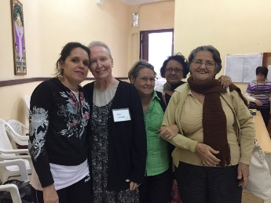
As if that is not enough, both Beidy and Ari continue to look for Spiritual growth. They have spent the last three years focused on service, now it is time to focus on Spiritual growth. Every 15 days or so, 7 or 8 people meet with the pastors and have discussion on what is Spiritual growth, how they are growing and what all of this means.
By this time, Ari has joined us, and shares with us that all of these ministries are not done by a huge church with huge numbers, but with only 85 active members and an attendance 80-90 people. Small in numbers, big in Spirit. These very encouraging and inspiring ministries are all self-sustaining, with any outside resources used for specific groups. An example of these outside resources is a new partnership with Central Presbyterian Church in Athens, Ga., which began about one year ago.
Central Presbyterian Church of Matanzas looks to the future with four mission churches in Eastern part of Cuba serving not only Cubans but also Koreans, all with the hopes and prayers that they will become independent churches. I join in that prayer as well.
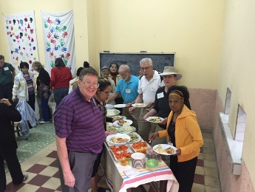
After a very delicious lunch where we were asked to sit next to our Cuban and American friends, it was time for us to leave. A quick stop was now made to St. Peter’s Cathedral, but it was not open to visitors today. A Franciscan Church that is beautiful to look at.
Our final stop for the day was to Versailles, where Rev. Carlos Ham is the pastor, and also the President of the Seminary. Carlos led a wonderful Bible Study for us and members of his church based on II Corinthians 5:20-6:7. As conversations between the USA and Cuba continue to be had, it is important Carlos said that we remember we are all Ambassadors.
On December 17, 2014 the world was surprised as two leaders gave two speeches at the same time. What would they say? Maybe prisoners would be exchanged. Yes, Raoul Castro and Barack Obama announced this and also that there would be harmonization between the two nations. There is a long ways to go, but a sign of changes is the embassy opening.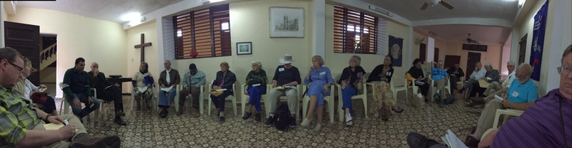
Two flags of two different nations would rise and would fly into different cities, and two ambassadors would be appointed, but again, the reality is we’ve always had ambassadors. Verse 20: We are ambassadors thru Christ. Even with the lack of communications, even with the embargo in place, Christian people have been ambassadors for Christ thru these people.
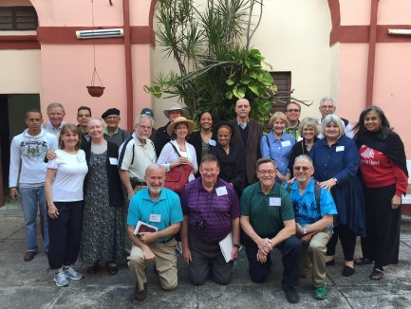
Both Castro and Obama mentioned Pope Francis as a catalyst to this movement, but what no one mentioned was the Church. What the Church did, thru prayers and as a house for the Ambassadors of Christ was done anonymously. We are ambassadors for Christ, Carlos kept repeating. A Second point of this study, a ministry of reconciliation. To be reconciled with God, you have to be reconciled with your neighbor. As Ambassadors of Christ we are to carry out reconciliation to each other despite our differences. Rev. Carlos prayed for normalization between these two countries every Sunday. Crazy? Yes, but prayer and intercession of people worldwide, WORKS, or is in the progress of working. We do this he said not for economic gain, but as verse 20 states: We are therefore Christ’s ambassadors, as though God were making his appeal through us. We implore you on Christ’s behalf: Be reconciled to God.
A final point in this study. We need to pray for all the world leaders, so that their right of good can be in all leaders, domestic and foreign. Do I pray for all leaders of the world? Maybe I should. Chapter 6:1, As God’s co-workers we urge you not to receive God’s grace in vain. The work we are doing as ambassadors for God is right and it is good, and it can be effectively practiced to our nations, so that we do not do anything in vain. We do not know what the future holds, but we know who holds it and that is what 6:1 demonstrates.
Perhaps, for me, the most sobering aspect of the Bible study is the effect that the embargo has had on the Cubans and hearing that first hand. Hearing that they have survived on faith, knowing that God will always provide. Could I live that way? I’ve noticed time and time again this week that the Cubans rely on God to see them thru. I feel, that an American, we, or maybe I, probably I, have way too much stuff. When I go looking for God, do I find God, or do I find stuff? I pray I find God. It is hard sometimes to see yourself in the mirror that way.
Recently, I was asked why we should lift the embargo, and I remember something I heard at this study. Lift the embargo for economics and trade, yes, but also for food. Lift it to help people and to love them. We love, because we were loved first.
That love came into the spotlight again as we were invited by the students of the Seminary to join them in a party celebrating St. Valentine’s Day. It was a blast to watch them have fun with each other, and I remember more than anything the smiles on their faces. This is the Cuba I want to remember, where laughter is heard and joy shared. Where we witness a testimony of love and dance the night away, dancing as strangers, and as friends. Dancing not as Cubans or Americans, but as Ambassadors for Christ.
The night is late, and I find myself again sitting on the wall overlooking the Bay of Matanzas, I lower my head in prayer remembering the words of Thomas Merton, remembering the events of the day, the people met, the food ate, and the stories heard. Thank you God, for you are truly in all.
Friday, February 12, 2016---Suzan Codington
After the mother of all sunrises, we enjoyed a 7:30 breakfast of omelet, bread, and mango juice, accompanied by harmonies from the chapel. At 8:00, greeted once again by Orestes, our punctual “coachman,” and our snorting “coach,” we attuned our ears to our valiant comandante (Marilyn), who gave us our marching orders. At her request, Glen Thorp prayed, recalibrating our hearts upward. Dorothy led us in a thought-provoking devotional using Psalm 100: “What is a happy church? What is a happy person? How do we assist others in discovering happiness?” Some answers were “acceptance, validation, purpose, belonging, living in the present.” [see Rob Bell’s book, Living in the Present)
Because of cooler-than-usual 65-degree weather, Orestes pulled on hat, jacket, and gloves! Then, as the day warmed up, he began shedding, all the way down to a sleeveless sports shirt. Yet he proved to be alert, not only to changing weather conditions, but also to traffic and pedestrians. A man out of nowhere suddenly crossed the street in front of the moving bus, but our valiant bus driver calmly maneuvered away from him! Yosmel said, “Orestes has 10 eyes!” We thank the Lord for his alertness!
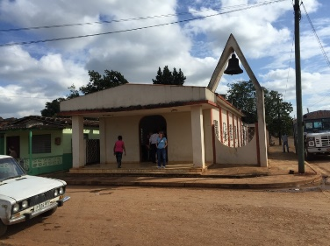
Along the way we passed men trimming the grass with swing blades and machetes. Many people were standing on sidewalks at various stops, waiting for buses to carry them to work. Buses passed us, loaded to the gills with passengers; those standing were holding onto overhead straps to keep from falling into the seated passengers. As to transportation, we passed people on regular bicycles, bicycles carrying huge loads, “bicitaxis” (bicycles with carriages for passengers), “cocotaxis” (tiny ladybug-like cars), “coches” (horse-and-buggies with passengers), and mostly 1950s and ’60s cars (Chevy, Ford, Buick, Plymouth, Oldsmobile...) puffing out choking fumes. All along the highway we passed horses tethered to fences, trees, or rocks. Sugar cane fields ready for the harvest stretched for miles, and many farmlands were enclosed by remarkable fences of thin trees; the posts from the amálcigo tree end up sprouting and making fences that don’t rot!
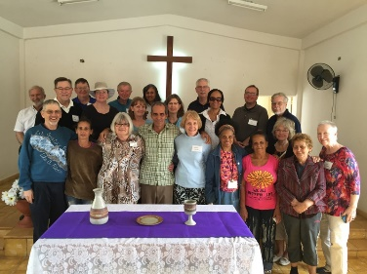
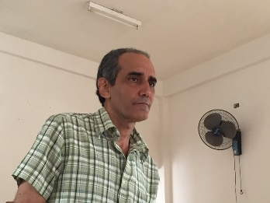
After awhile we arrived in the small community of Manguito (around 5300 people), founded in 1814; early on the people used a central mango tree as a gathering place, hence the name “Manguito” (little mango). In the small sanctuary of the Manguito Pres. Church that faces the main road and railroad, Pastor Armando Guedes Hernández, a visiting pastor who serves as moderator of the session, greeted us, and Marilyn explained our purpose in coming—to establish partnerships. Pastor Armando answered our questions about the church... Twelve or thirteen adults and 6-8 children participate in this church, founded between1919-1920 as a mission of the San José de los Ramos Church; the property had been bought by a U.S. missionary. All denominations seem to reach out to the community. The Presbyterian church’s unique contribution is its ecumenical emphasis on bridge building and reconciliation, in particular its service of “Living Water for the World.” North Palm Beach Pres. Church has a relationship with this church. After presenting gifts to the pastor and church, we were served refreshments in the fellowship room. Jesus Adrian Romero’s song “¿Cómo te lo puedo decir para que pueda entender?” (How can I tell you so that you can understand?) was playing in the background. At the back side of the building, a very small, mildewy room faces major renovation for the residence of a pastor and his wife who will soon be sent from the seminary.
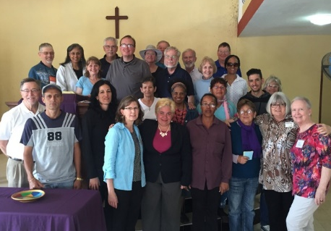
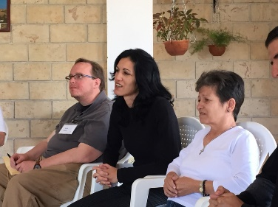
Next, our team headed for the Jagüey (pronounced “highway”) Grande Church, whose new pastor, Liz Eleine Capo Lima, and several leaders of the WOC greeted us. After warm introductions, we were given a short history of the city and the ministry of the church... No residential pastor for a long time; in a period of reorganization; Sun. School at 10:00, worship at 11:00; the church is open to anyone; Bible studies on Thursday to start in March; fellowship Sun. evening; women’s organization (make crafts, sell, and use $ for ministry of WOC; some offerings go to church and to presbytery; letter-writing ministry); developing a library; prayer ministry; 30-40 active members; strong ecumenical relations – 5 official church facilities and 16 denominations; population of town: 5300. The Cuban Pres. Church appoints leaders, but they are moving towards a calling. Liz shared her story; George made a moving presentation to the pastor of a stoll made by his sister; we shared gifts for the children’s ministry; and then enjoyed a tour. The church boasted beautiful renovations, including a balcony. Last Sunday the church celebrated its 15th anniversary of its organization. We finished our visit with a meal in the restaurant across from the church. Although it was a long wait, the food was delicious. Our helpings, however, were huge, so several of us separated our untouched food and put it in plastic bags; we gave the bags to the elders, who were ecstatic, saying they could feed their families for several days with it. Whoa! We were stunned by how much we take for granted.
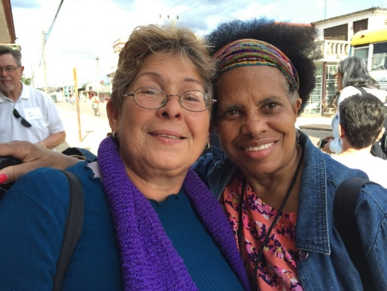
For our final evening devotional, Marilyn shared the essence of Sara Miles’ essay “The Most Important Word in the Bible - With.” (“The Word was with God. I am with you always. Immanuel means ‘God with us’....”) The important thing is not doing for; rather, being with. We might get changed by truly being with others. Herb shared his restlessness to move to the next step in our partnership efforts. Perhaps we need to think of resources we can contribute (training, books, posters, toys, pictures, sewing machines, crafts, movie projector, Christian movies) but most of all, ourselves. The Cuban churches want to build relationships that will be ongoing. We need to use our voices to influence, to tell the stories, to engage our congregations in the Cuban mission.

